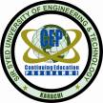**Sir Syed University of Engineering & Technology**

**Continuing Education Programme**

**University Road, Karachi-75300. Phone# 92 21 34800420; Fax# 92 21 34982393**

E-mail:- **cep@ssuet.edu.pk**; Website: - **http://www.ssuet.edu.pk/cep**

***Building Intelligent UI and VUI Apps with Cloud Native Python***

**CERTIFICATE IN AI App development**

**using Machine Learning, Voice, fintech, blockchain, Big data and cloud native computing**

A datascience Program DEsigned for absolute beginners:

getting you ready for the new era of computing enabled by the rise of artificial intelligence (AI), microservices, Big data, Fintech, blockchain and Voice User Interface (VUI) applications

now anyone can join the fourth industrial revolution

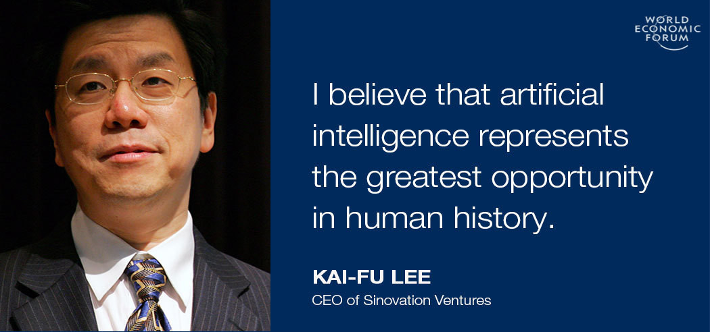

***Free Seminar on Sunday, October 15, 2017 at 1:30 pm***

***A Two-Semester Course, Classes only on Sundays***

***Classes starting from Sunday, October 22, 2017***

***Questions?***

[***https://www.facebook.com/groups/deep.learning.edu/***](https://www.facebook.com/groups/deep.learning.edu/)

Machine learning and deep learning represents a key evolution in the fields of computer science, data analysis, software engineering, and artificial intelligence. Some commentators are calling AI the fourth industrial revolution. Others are calling it the new electricity. An incredible amount of money is pouring into companies focused on AI/ML and Data Science, as it has the potential to revolutionize most, if not all industries. In the next decade, more than 50% of jobs in the world will be replaced by AI, ranging from translators, editors, assistants, stock traders, securities, drivers, salespeople, customer service reps, accountants, nannies and so on. Continuing Education Programme is extremely pleased to announce a two-semester certificate course covering deep learning and data science. This program will teach you how to become a machine-learning engineer and data scientist using Python, Anaconda, Keras, and Tensorflow, and apply predictive models to massive data sets in fields like finance, healthcare, education, and more.

The classes and labs will be held on Sundays only. It will introduce you to the [Machine Learning Engineer Nanodegree](https://www.udacity.com/course/machine-learning-engineer-nanodegree--nd009) awarded by Google and Udacity and [Microsoft Professional Program Certificate in Data Science](https://academy.microsoft.com/en-us/professional-program/data-science/) and help you to take the first steps in becoming an expert in this cutting edge and highly in demand field.

The course does not require any background in software development or statistics anyone can join. In addition, it is also a ground-breaking course for Mobile, Web and IoT App developers that will allow them to build intelligent and the state-of-the-art apps in the fields like finance, healthcare, education, computer vision, automatic speech recognition, natural language processing, audio recognition, bioinformatics, internet of things and many other areas. In this course, you’ll develop a clear understanding of the motivation for deep learning, and design intelligent systems that learn from complex and/or large-scale datasets.

Google, Microsoft, and Amazon, have all been heavily investing in Artificial Intelligence (AI). Recently, each has launched new enterprise-scale AI-as-a-Service and APIs that will allow an average developer to build smart and intelligent apps. This is the dawn of a new era in computing.

The “Google Brain” team has revolutionized the artificial intelligence (AI) industry by developing TensorFlow, the latest and greatest deep learning library. It is one of the fastest-growing and most exciting fields out there. The library runs both on the mobile as well as in the cloud. TensorFlow can run on multiple CPUs and GPUs. It runs on server systems, as well as on mobile computing platforms, including Android and Apple's iOS.

Once you’ve trained machine learning models on your data, but how do you put them into production? When you have tens of thousands of model versions, each written in any mix of frameworks and exposed as REST API endpoints? This course explains why AI and machine learning are a natural fit for serverless and cloud native computing —a general architecture for scalable and serverless and microservices based machine learning in production. The goal of this course is to teach you to build and deploying AI applications as easily as creating a website.

We are on a cusp of a chatbot revolution that will be extremely important to human culture. Chatbots are already everywhere; they are present in e-commerce, banking, health care, education and libraries. We will end this course by learning to build intelligent and scalable cloud native voice and text-based chatbots.

The course consists of three semesters of coursework.

**Fee: Rs. 6,000 per Semester (The duration of the course is three semesters).**

**Classes only on Sundays.**

**Semester AI 301**

Building Voice User Interfaces (VUIs), Fintech and Big Data

Class on Sunday: 5:30 pm to 7:30 pm

**Semester AI 201**

AI & Machine Learning

Class on Sunday: 5:30 pm to 7:30 pm

**Semester AI 101**

Data Science and Cloud Native Python

Class on Sunday: 1:30 pm to 4:30 pm

**A Three-Semester AI Program in Data Science, Machine Learning, Deep Learning, and Voice UI**

If interested and have any Questions Join:

<https://www.facebook.com/groups/deep.learning.edu/>

**AI 101: Data Science and Cloud Native Python**

**Module A: Introduction to Linux and Bash**

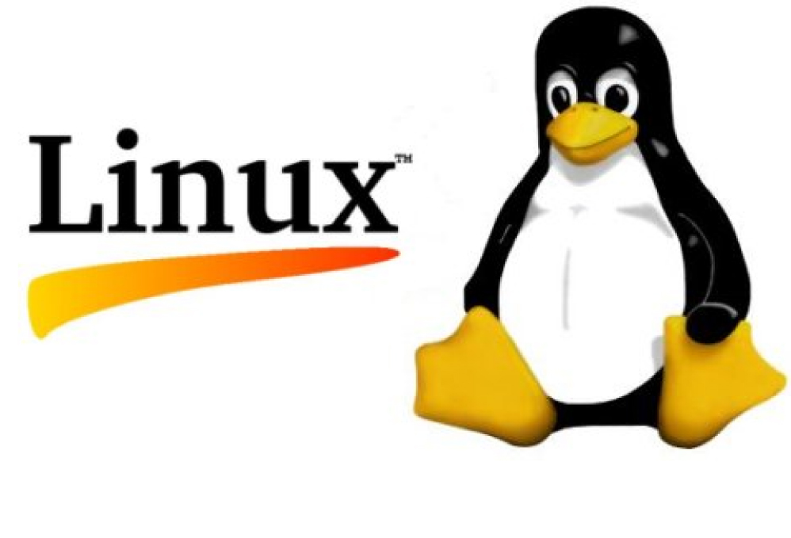 Linux containers are poised to take over the world; we will start our course with an introduction of Linux and the command line. For many non-technical people, the command line (also referred to as CLI, Terminal, bash, or shell) is a place of mystery. However, you only have to know a handful of basic commands to start feeling comfortable. In this module we will cover the basic commands to get you started.

**Module B: Version Control with Git**

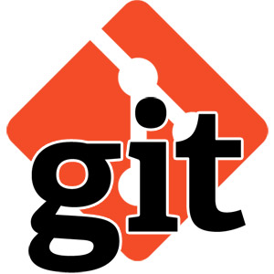 You won't find a top programmer, web developer, or AI enginner who doesn't use version control. Because it helps you produce better results and makes collaboration easy. Around the world, in teams large and small, Git is an essential part of the tool chain. We will start learning our learning process by covering Git and Github.

**Module C: Object Oriented and Functional Programming using Python**

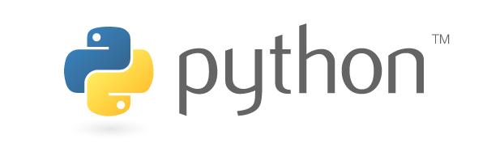In the second module of the course, you'll learn about basic programming concepts, such as lists, dictionaries, classes, functions and loops, and practice writing clean and readable code with exercises for each topic. You'll also learn how to make your programs interactive and how to test your code safely before adding it to a project. It is a fast-paced, thorough introduction to programming with Python 3.6 that will have you writing programs, solving problems, and making things that work in no time. In this module we will also learn Git, the distributed version control system. We will also review Git based GitHub and BitBucket services.

**Module D: Python Microservices Development**

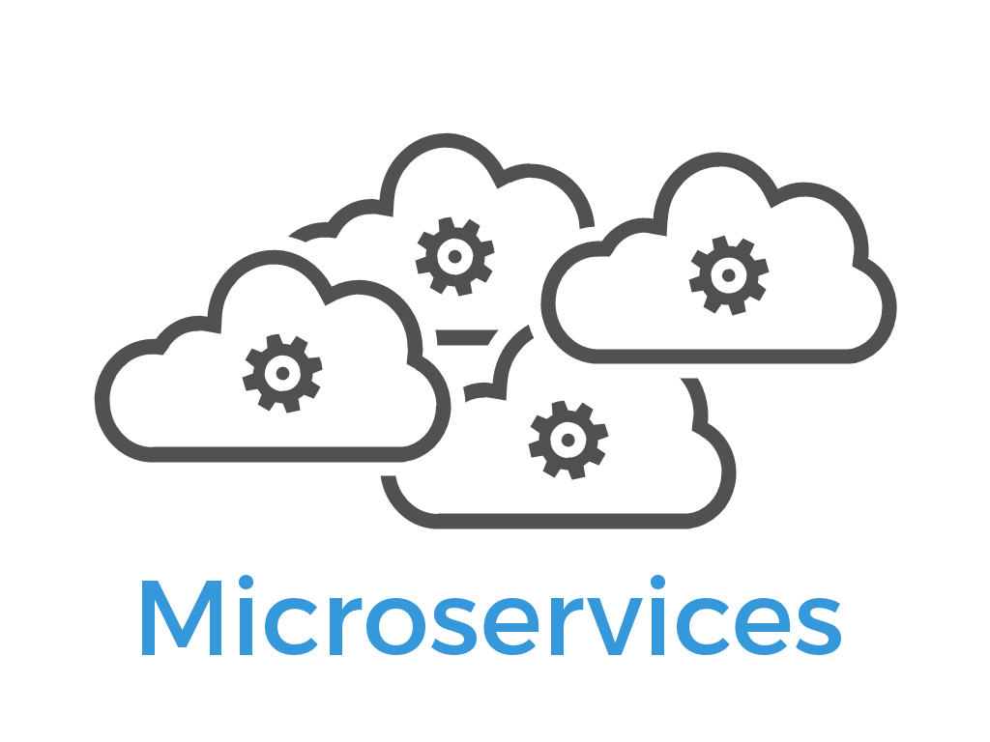 In recent years REST (REpresentational State Transfer) has emerged as the standard architectural design for web services and web APIs. In this module I'm going to show you how easy it is to create a RESTful web service using Python and the Flask microframework.

**Module E: Build AI Microservices for Cloud Native Deployments**

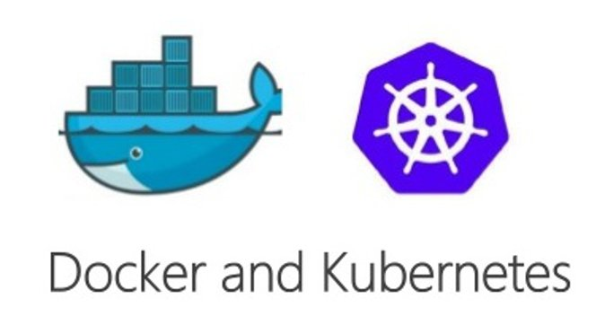In this module we will learn to use Docker, Kubernetes, and GKE to simplify server deployment and use continues integration and deployment strategy. For developing API we will use Flask and gRPC. If user authentication and storage are required we will use Firebase, which is a backend as a service and its real-time document database Firestore.

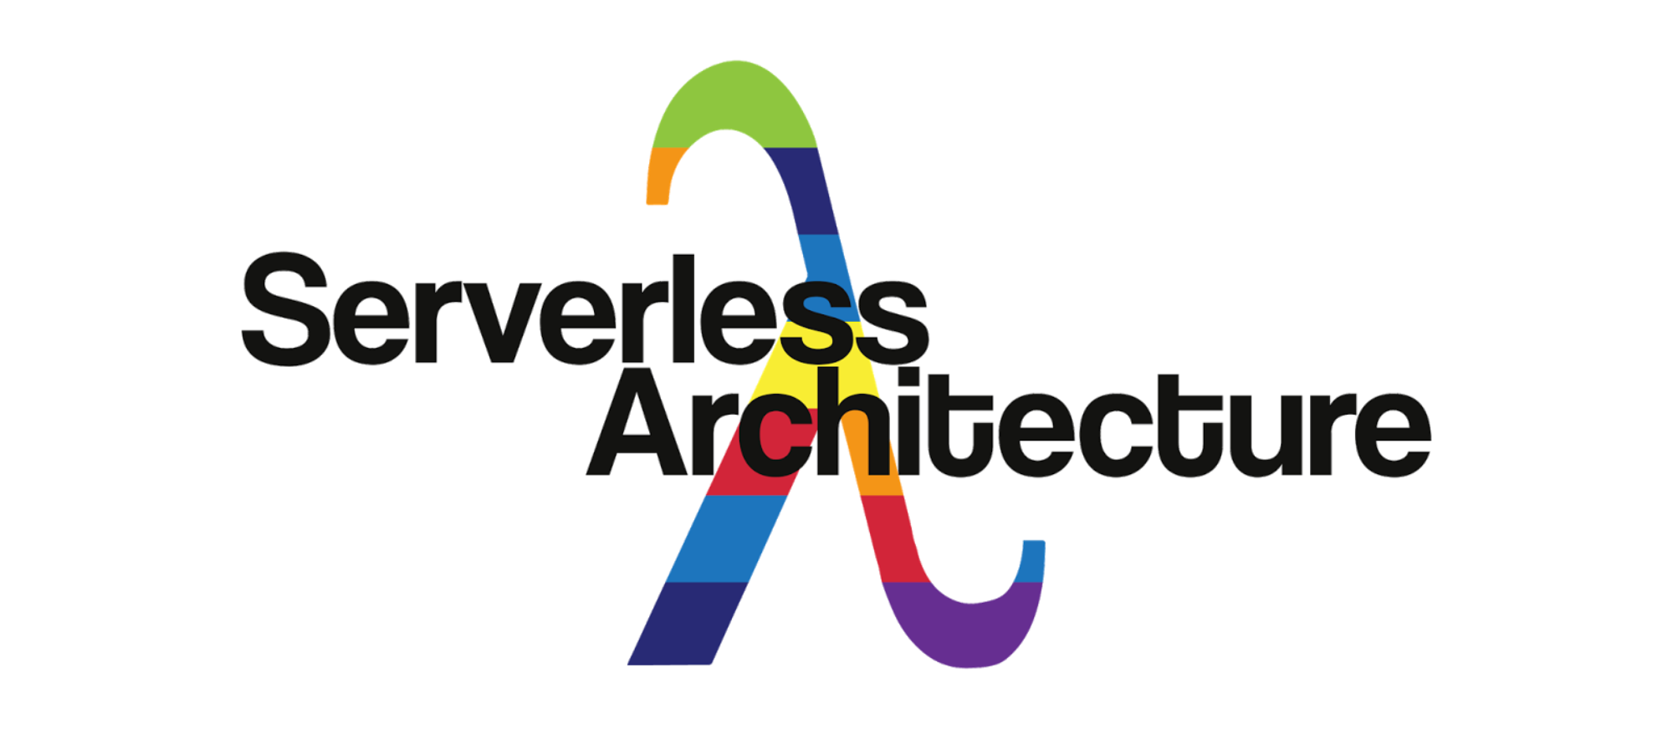

**Module F: Serverless Ninoservices using Chalice**

Chalice is a serverless microframework that makes it simple for you to use AWS Lambda and Amazon API Gateway to build serverless nanoservices in Python.

**Detailed Course Outline Semester AI 101:**

|  |  |  |
| --- | --- | --- |
| **Week** | **Topic** | **Learning Material** |
| 1-2 | Introduction to Data Science | <https://www.youtube.com/watch?v=z1kPKBdYks4>  Data Science for Beginners (5 Videos): <https://docs.microsoft.com/en-gb/azure/machine-learning/studio/data-science-for-beginners-the-5-questions-data-science-answers>  Homework (Complete the following course):  <https://cognitiveclass.ai/courses/data-science-101/> |
|  | Build Intelligent Apps: AI as Microservices | <https://wikibon.com/building-ai-microservices-for-cloud-native-deployments/>  https://jaxenter.com/machine-learning-interview-reichhelm-138821.html |
| 3 | Getting Started with Python | Chapter 1, Python Crash Course by Eric Matthes |
|  | Variables and Simple Data Types | Chapter 2, Python Crash Course by Eric Matthes |
| 4 | Version Control with Git | Chapters 1, 2, and 3, Learn Version Control with Git: A step-by-step course for the complete beginner by Tobias Günther |
| 5-6 | Introducing Lists | Chapter 3, Python Crash Course by Eric Matthes |
|  | Working with Lists | Chapter 4, Python Crash Course by Eric Matthes |
| 7 | If Statements | Chapter 5, Python Crash Course by Eric Matthes |
|  | Dictionaries | Chapter 6, Python Crash Course by Eric Matthes |
| 8 | User Input and while loops | Chapter 7, Python Crash Course by Eric Matthes |
|  | Functions | Chapter 8, Python Crash Course by Eric Matthes |
| 9 | Classes | Chapter 9, Python Crash Course by Eric Matthes |
|  | Files and Exceptions | Chapter 10, Python Crash Course by Eric Matthes |
| 10 | Sorting, List Comprehensions, Generators and Iterators, and Randomness | Chapter 1 & 2, Data Science from Scratch by Joel Grus |
| 11 | Functional Tools, enumerate, zip and Argument Unpacking, and args and kwargs, | Chapter 2, Data Science from Scratch by Joel Grus |
| 12 | Visualizing Data | Chapter 3, Data Science from Scratch by Joel Grus |
| 13-14 | Understanding Microservices and Discovering Flask | Chapters 1 and 2, Python Microservices Development by Tarek Ziade |
|  | Introducing Cloud Native Architecture and Microservices | Chapter 1, Cloud Native Python by Manish Sethi |
| 15-16 | Building React Web Apps using Microservices in Python | Chapter 2-5, Cloud Native Python by Manish Sethi |
| 17-18 | Creating Docker Images and Containers | <https://medium.com/@sachin.abeywardana/docker-for-data-science-4901f35d7cf9>  <https://www.analyticsvidhya.com/blog/2017/11/reproducible-data-science-docker-for-data-science/>  Chapters 1-7, Docker Deep Dive by Nigel Poulton |
|  | Containerizing an App | Chapter 8, Docker Deep Dive by Nigel Poulton  <https://medium.com/statuscode/dockercheatsheet-9730ce03630d> |
| 19 | Using Linux OS and the Command Line inside a Container | Chapters 1-7, Linux: Easy Linux for Beginners by Felix Alvaro |
| 20-24 | Understanding Kubernetes Pods, ReplicaSets, Services, and Deployments | <http://www.bailey.st/A-Kubernetes-cluster-up-and-running-in-less-than-five-minutes/>  Chapters 1-10 and 17, Kubernetes in Action by Marko Lukša |
| 25 | Using Ngnix in Containers | NGINX: A Practical Guide to High Performance  <https://www.nginx.com/resources/library/nginx-practical-guide-high-performance/> |
| 26 | Serverless Nanoservices using Chalice | <https://github.com/aws/chalice>  <https://aws.amazon.com/blogs/developer/build-and-deploy-a-serverless-rest-api-in-minutes-using-chalice/>  <https://www.slideshare.net/ewolff/nanoservices-and-microservices-with-java> (Micro vs Nano) |
| 27 | Building AI Microservices and Nanoservices | <https://wikibon.com/building-ai-microservices-for-cloud-native-deployments/>  <https://aws.amazon.com/blogs/ai/tag/aws-lambda/> |
|  | Project: Build a Cloud Native Microservices based React App |  |

**Semester AI 201: AI and Machine Learning**

**Module A: AI-as-a-Service**

If your app requires voice-to-text support, until recently, you had little choice but to pencil a few extra months into your product development timeline, while your data-scientists and developers put together a scalable voice module. Now, with services from Google, Amazon, and Microsoft, AI is a matter of a simple API integration. Isn’t that something!

**Module B: Advanced Python Libraries with Anaconda**

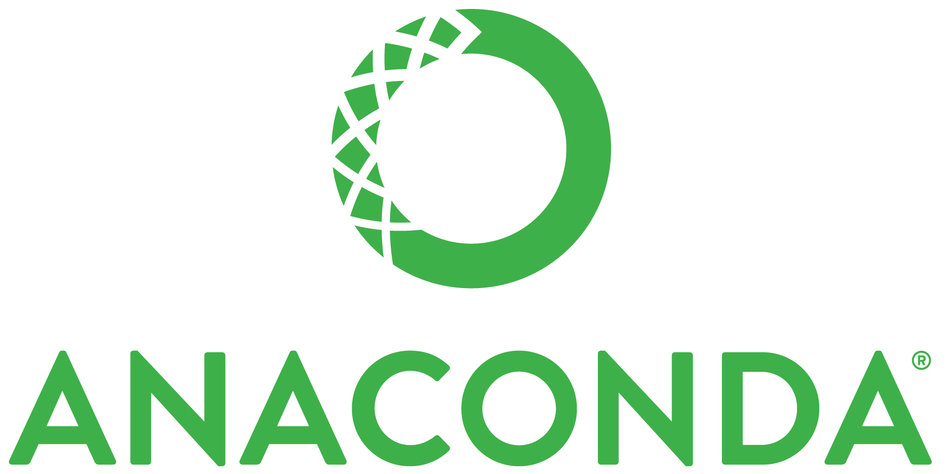In this module we will also introduce you to Anaconda which is the leading open data science platform powered by Python. The open source version of Anaconda is a high performance distribution of Python and R and includes over 100 of the most popular Python, and R packages for data science, such as NumPy, and Matplotlib, etc.

**Module C: Introduction to Linear Algebra and Statistics**

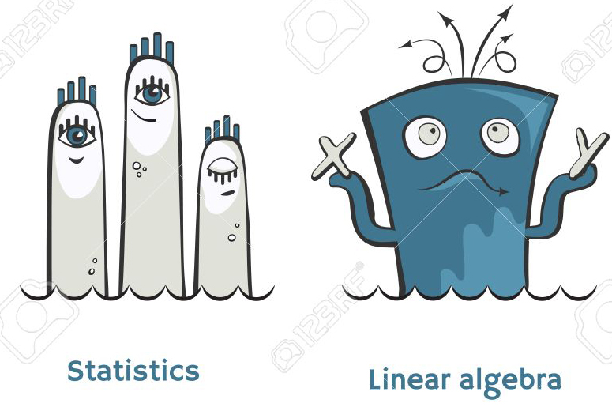

In this part of the course we will introduce the basic mathematical and statistical concepts that are needed to practice data science and understand deep learning. We will also implement these concepts in Python and TensorFlow.

**Module D: Data Science Essentials**

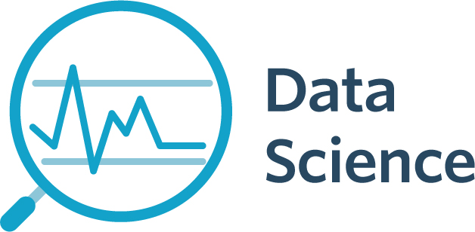Learn key concepts and techniques used to perform data science; including statistical analysis, data cleansing and transformation, and data visualization with Python.

**Module E: The Fundamentals of Deep Learning with Keras with TensorFlow Backend**

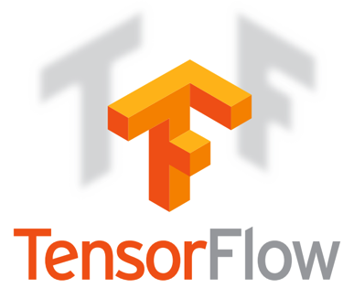Before implementing deep-learning algorithms, we will first familiarize ourselves with mathematical blocks of neural networks theory. We going to start by geting our hands dirty writing some simple Keras code right away! And then move on to advanced deep learning concepts. This module will also cover some essential advantages of Keras to convince you it’s the deep-learning library of choice.

**Module F: Deep Learning in Practice**

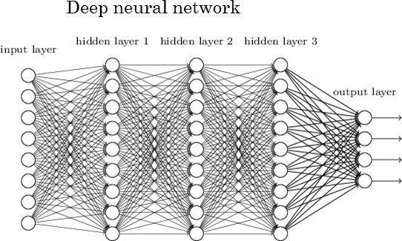This module is structured around a series of practical code examples, demonstrating on real world problems every the notions that gets introduced. We strongly believe in the value of teaching using concrete examples, anchoring theoretical ideas into actual results and tangible code patterns. These examples all rely on Keras, the Python deep learning library. We will cover Deep Learning for computer vision, text and sequences, finance, and advanced neural network design.

**Module G: Introduction to Cloud Machine Learning Engine**

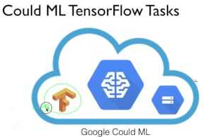In the last module we will learn about Google Cloud Machine Learning Engine which is a managed service that enables developers to easily build machine learning models, that work on any type of data, of any size. It allows you to create your model with the powerful TensorFlow framework in the cloud and can support thousands of users and TBs of data seamlessly.

**Course Outline Semester AI 201:**

|  |  |  |
| --- | --- | --- |
| **Week** | **Topic** | **Learning Material** |
| 1, 2 | NLP-as-a-Service (Insights from Unstructured Text) | <https://cloud.google.com/natural-language/>  <https://code.facebook.com/posts/181565595577955/introducing-deeptext-facebook-s-text-understanding-engine/> |
| 3, 4 | Vision-as-a-Service (Insight from Images) | <https://cloud.google.com/vision/>  <https://aws.amazon.com/rekognition/>  <https://azure.microsoft.com/en-us/services/cognitive-services/face/>  <https://azure.microsoft.com/en-us/services/cognitive-services/emotion/> |
| 5 | Cloud Video Intelligence As a Service | <https://cloud.google.com/video-intelligence/> |
| 6 | Text to Speech As a Service | <https://aws.amazon.com/polly/> |
| 7 | Speech Recognition As a Service | <https://cloud.google.com/speech/> |
| 8 | Linear Algebra | Chapter 4, Data Science from Scratch by Joel Grus |
| 9 | NumPy Fundamentals | Chapters 1-3, NumPy 3rd Edition by Ivan Idris |
| 10 | Statistics and Regression | Chapter 5, Data Science from Scratch by Joel Grus |
| 11-12 | Data Science Methodology | <https://cognitiveclass.ai/courses/data-science-methodology-2/> |
| 13 | A machine-learning odyssey | Chapter 1, Machine Learning with TensorFlow by Nishant Shukla  <https://www.youtube.com/watch?v=rbsqaJwpu6A>  <https://www.youtube.com/watch?v=wvsE8jm1GzE> |
| 14 | TensorFlow essentials | Chapter 2, Machine Learning with TensorFlow by Nishant Shukla  <https://www.quora.com/Is-there-any-advantage-of-running-Tensorflow-in-a-docker-container-rather-than-just-pip-installing-it>  <http://www.science.smith.edu/dftwiki/index.php/Tutorial:_Using_Tensorflow_with_Docker>  <https://www.youtube.com/watch?v=W3bk2pojLoU>  <https://www.youtube.com/watch?v=_TPo53j9nsc>  <https://medium.com/@cswiggz/quick-start-to-tensorflow-in-docker-with-a-gui-39414245251f> |
| 15, 16 | Linear regression and beyond | Chapter 3, Machine Learning with TensorFlow by Nishant Shukla |
| 17, 18 | A gentle introduction to  Classification | Chapter 4, Machine Learning with TensorFlow by Nishant Shukla |
| 19 | What is Deep Learning? | Chapter 1, Deep Learning with Python by François Chollet  <https://www.youtube.com/watch?v=uXt8qF2Zzfo> |
| 21 | Mathematical blocks of Neural Networks | Chapter 2, Deep Learning with Python by François Chollet |
|  | Introduction to Keras | Chapter 2, Deep Learning with Python by François Chollet |
| 22 | Getting started with neural networks with Keras | Chapter 3, Deep Learning with Python by François Chollet |
| 23 | Machine Learning in-depth | Chapter 4, Deep Learning with Python by François Chollet |
| 24 | Deep learning for computer vision | Chapter 5, Deep Learning with Python by François Chollet |
| 25 | Deep learning for text and sequences | Chapter 6, Deep Learning with Python by François Chollet |
| 26, 27 | Advanced neural network design | Chapter 7, Deep Learning with Python by François Chollet |
| 28 | Generative deep learning | Chapter 8, Deep Learning with Python by François Chollet |
| 29 | Cloud Machine Learning Engine | <https://cloud.google.com/ml-engine/> |
|  | Deploying Tensorflow on Kubernetes | <https://github.com/tensorflow/k8s> |
|  | Deep Learning Project |  |

**AI 301: Building Voice User Interfaces (VUIs), Fintech, and Big Data**

**Module A: Introduction to VUI History and Design**

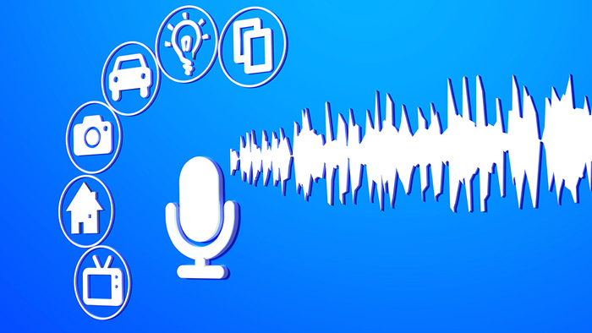We start this semester by showing you how to design and build great conversational experiences and delightful bots that help people be more productive, whether it’s for a new consumer service or an enterprise efficiency product.

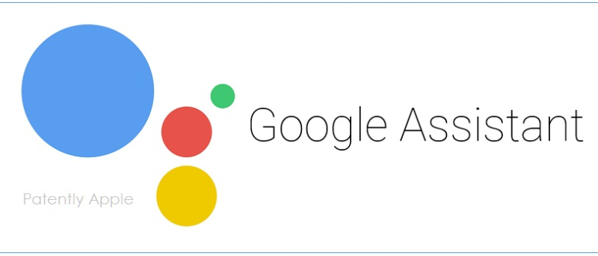**Module B: Google Assistant Intelligent and Scalable App Development**

In this module we will learn to build intelligent apps for the Google Assistant. Your apps can engage users through 1B+ devices including voice-activated speakers, Android phones, iPhones, Android TVs, and more. We will build these voice based conversational user interface apps that are intelligent and scalable. We learn to build these apps using the AI, cloud native and serverless technologies we learnt in AI 101 and AI 201.

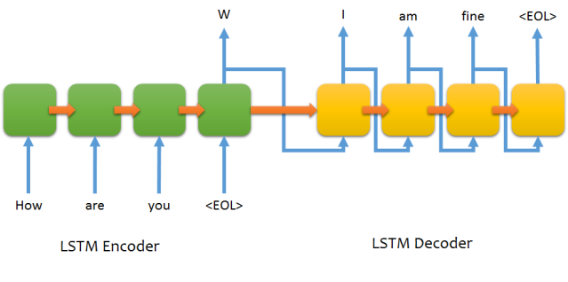**Module C: Sequence-to-sequence models for chatbots**

In this module, we’ll build a chatbot from scratch by feeding a neural network thousands of examples of input and output sentences. The algorithm will try to produce an intelligent natural language response to each natural language query. We’ll be implementing a neural network that uses two primary concepts taught in AI 201: multi-class classification and recurrent neural networks (RNNs).

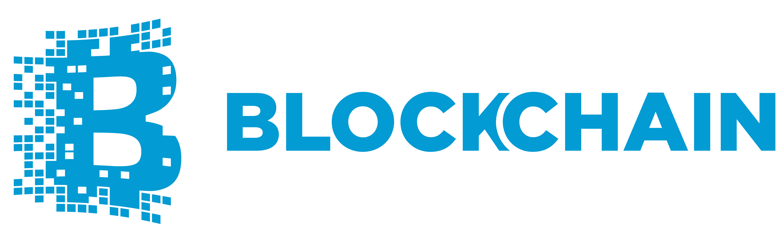**Module D: Programming the Open Blockchain with Python**

In this module, we will take a deep dive into blockchain applications, including how to combine the building blocks offered by this platform into higher-level applications.

**Module I E: Hadoop and Spark using Python**

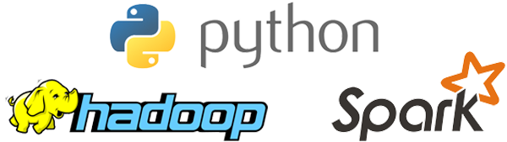

In this module we will cover basic concepts behind Hadoop, MapReduce, Pig, and Spark by applying various Python tools on Docker.

**Final Semester Project: End-To-End Intelligent Voice Based Intelligent App using Cloud Native Architecture**

At the end of the course, we’ll build a complete app with both an UI and VUI and it will use all the techniques learnt through out the program.

**Detailed Course Outline Semester AI 301:**

|  |  |  |
| --- | --- | --- |
| **Week** | **Topic** | **Learning Material** |
| 1-3 | Designing Voice User Interfaces: Principles of Conversational Experiences | <https://www.amazon.com/Designing-Voice-User-Interfaces-Conversational-ebook/dp/B01NALL1Q0/>  <https://www.amazon.com/Designing-Bots-Creating-Conversational-Experiences-ebook/dp/B0723B91XD/ref=sr_1_3> |
| 4-12 | Google Assistant Intelligent and Scalable App Development | <https://developers.google.com/actions/>  <https://dialogflow.com/> |
| 12-14 | Sequence-to-sequence models for chatbots | Chapter 11, Machine Learning with TensorFlow by Nishant Shukla  <http://suriyadeepan.github.io/2016-06-28-easy-seq2seq/> |
| 16 | Introduction to Fintech | <https://www.amazon.com/Fintech-Flash-Financial-Technology-Made-ebook/dp/B06Y1N5476/ref=sr_1_1> |
| 17-18 | Programming the Open Blockchain with Python Microserices | <https://www.facebook.com/confidencenyirenda/videos/506908552980833/>  <https://bitsonblocks.net/2015/09/09/a-gentle-introduction-to-blockchain-technology/>  <https://www.xenonstack.com/blog/blockchain-apps-deployment-using-microservices-with-docker>  <http://ecomunsing.com/build-your-own-blockchain> <https://www.amazon.com/Blockchain-Beginners-Understanding-Technology-Cryptocurrency-ebook/dp/B074V6FPQM/ref=pd_sim_351_5>  <https://www.amazon.com/Mastering-Bitcoin-Programming-Open-Blockchain-ebook/dp/B071K7FCD4/ref=sr_1_5> |
| 19-20 | Big Data: Hadoop and Spark with Python | <http://www.oreilly.com/programming/free/hadoop-with-python.csp> |
|  | Project: Build an End-to-End Voice Based Intelligent Enterprise App using Cloud Native Architecture |  |

**Text Books:**

1. 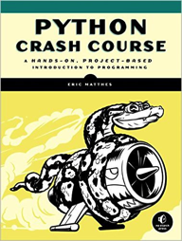 Python Crash Course: A Hands-On, Project-Based Introduction to Programming by Eric Matthes

<http://www.amazon.com/Python-Crash-Course-Hands--Project-Based-ebook/dp/B018UXJ9RI/>

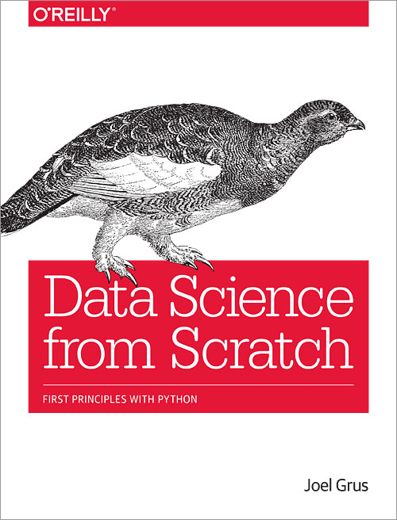

1. Data Science from Scratch by Joel Grus

<http://choonsiong.com/public/books/Data%20Science%20from%20Scratch.pdf>

1. 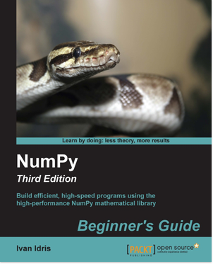NumPy 3rd Edition by Ivan Idris

<http://pdf.th7.cn/down/files/1602/NumPy,%203rd%20Edition.pdf>

1. 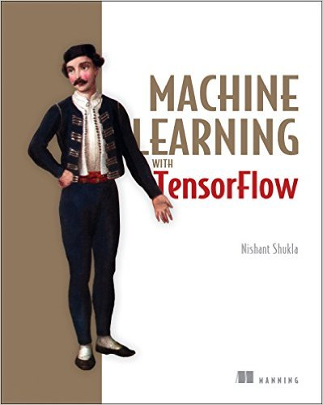Machine Learning with TensorFlow by Nishant Shukla

<https://www.manning.com/books/machine-learning-with-tensorflow>

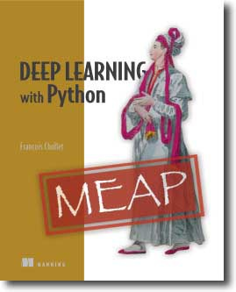

1. Deep Learning with Python by Francois Chollet

<https://www.manning.com/books/deep-learning-with-python>

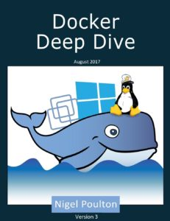

1. Docker Deep Dive by Nigel Poulton

<https://www.amazon.com/Docker-Deep-Dive-Nigel-Poulton/dp/1521822808/ref=sr_1_1>

1. Probability and Statistics Crash Course

<https://docs.google.com/file/d/0BzVk8fxj9agkVGlBWEVrMlRvaGs/edit>

1. Linear Algebra: Step by Step by Kuldeep Singh

<https://www.amazon.com/Linear-Algebra-Step-Kuldeep-Singh/dp/0199654441/>

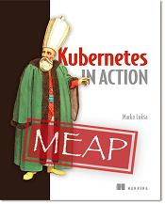

1. Kubernetes in Action by Marko Lukša

<https://www.manning.com/books/kubernetes-in-action>

1. Python Microservices Development by Tarek Ziade

<https://www.amazon.com/Python-Microservices-Development-deploy-microservices-ebook/dp/B01N7N7BU9/ref=sr_1_1>

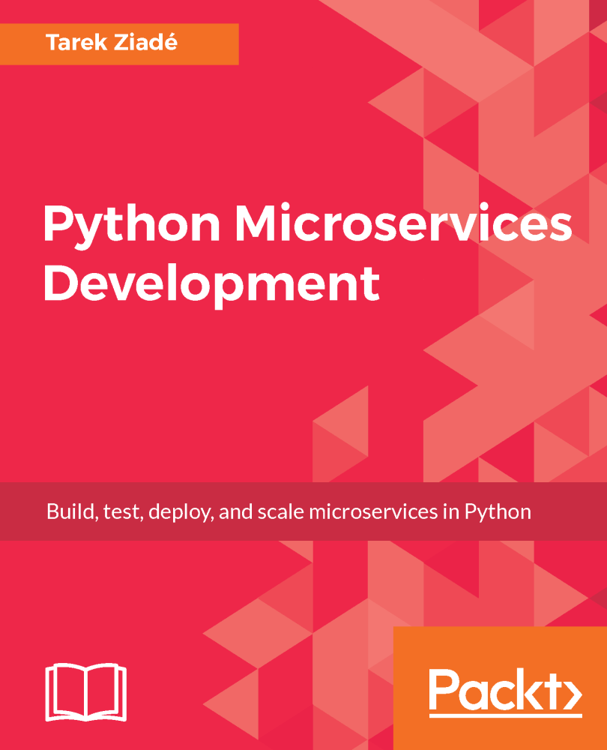

1. Learn Version Control with Git: A step-by-step course for the complete beginner by Tobias Günther

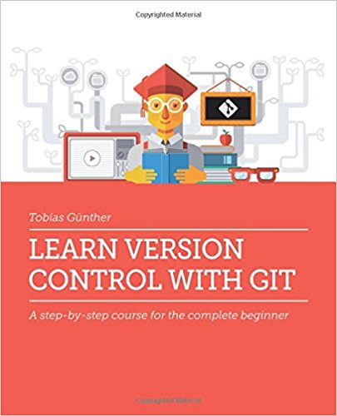

1. 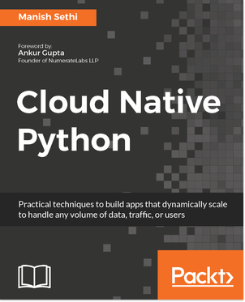 Cloud Native Python by Manish Sethi

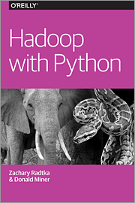

1. Hadoop with Python by Zachary Radtka and Donald Miner

<http://www.oreilly.com/programming/free/hadoop-with-python.csp>

**Reference Material:**

1. Deep Learning: Take machine learning to the next level

<https://www.udacity.com/course/deep-learning--ud730>

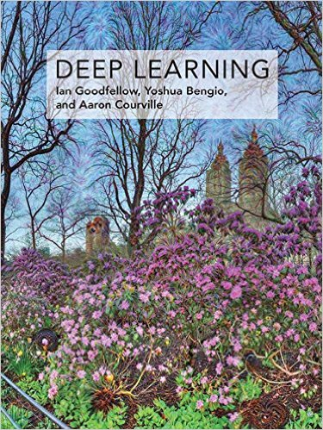

1. Deep Learning (Adaptive Computation and Machine Learning series) by Ian Goodfellow, Yoshua Bengio, Aaron Courville

Free Web Book: <http://www.deeplearningbook.org/>

1. 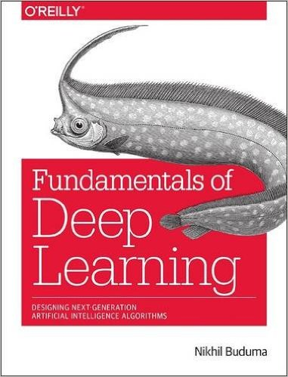Fundamentals of Deep Learning: Designing Next-Generation Machine Intelligence Algorithms by Nikhil Buduma

<http://shop.oreilly.com/product/0636920039709.do>

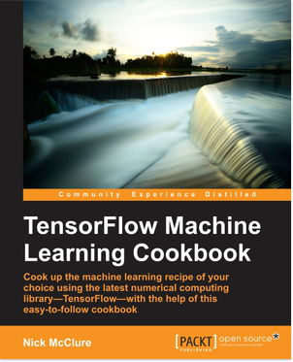

1. TensorFlow Machine Learning Cookbook by Nick McClure

<https://www.packtpub.com/big-data-and-business-intelligence/tensorflow-machine-learning-cookbook>

**The Teaching Team:**

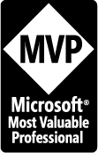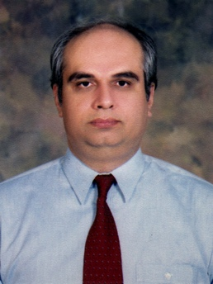**Mr. Zia U. Khan** (http://www.facebook.com/ziakhan.edu) will be the co-instructor for this course. He is the CEO of Panacloud (Pvt.) Ltd. He has fifteen years of experience in teaching computer science subjects and has extensive experience in development of business and financial software solutions. For eight consecutive years, in 2007, 2008, 2009, 2010, 2011, 2012, 2013 and 2014 he has received the Most Valuable Professional (MVP) Award from Microsoft USA. He has a Master of Science in Engineering (MSE), Master of Business Administration (MBA), and Master of Accountancy (MAC) in MIS, all three from Arizona State University. He is also a CPA and CMA in USA.

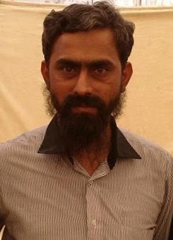

**Mr. Inam ul Haq** is the CTO of Zaavia and has over a decade of software development and teaching experience. He will be the co-instructor for this course. He is the academic supervisor of Saylani Mass Training Program, which is teaching computer science to thousands of students completely free of cost.



**Mr. Salah Uddin**, Data scientist at United Bank Limited.

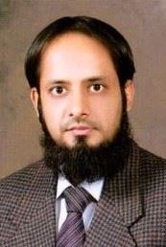

**Dr. Noman Islam** Associate Professor at Iqra University

**Mr. Anees Ahmed**, more than ten years of experience in Databases and Data Analysis



**Mr. Zeeshan Hanif**, CTO Panacloud with more than ten years of experience in application development.

**Mr. Khurram Raheel Meher** is a Senior Developer at Panacloud and Senior Teacher at Saylani Faisalabad

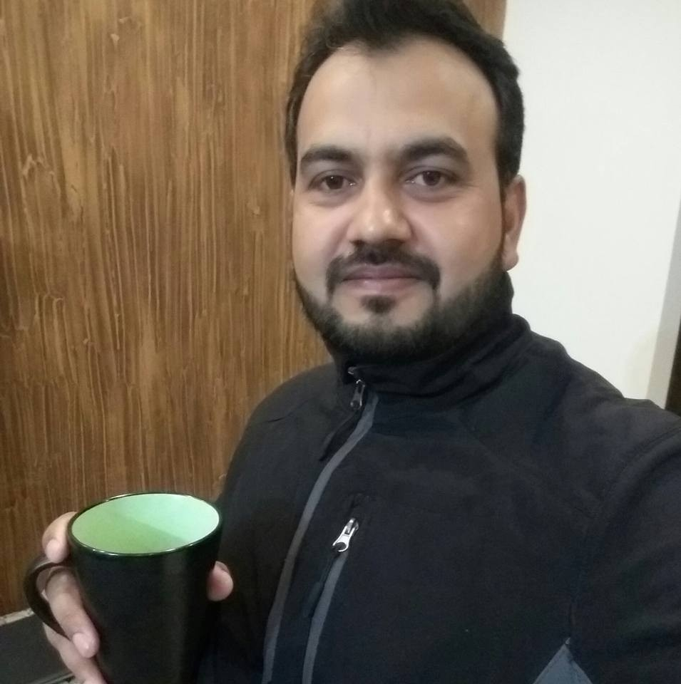**Dr. Muhammad Gufran**, Assistant Professor at FAST-NUCES Faisalabad



**Mr. Inzamam Malik** is a Voice User Interface (VUI) developer in Panacloud.